**Remote Software Installation**

Portfolio’s link: <https://retro-hue.github.io/Portfolio/>

**BY:**  Muhammad Faraz Malik

Date: 16th October,2024

**Table of Contents**

1. Introduction: .................................................................................................................. 3
2. Objectives: .................................................................................................................... 4
3. CCN Technique used: ................................................................................................... 5
   1. Virtualization:................................................................................................................... 5
   2. Centralized Authentication:.............................................................................................. 5
   3. Remote Management Tool: .............................................................................................. 5
4. Results Computed: ........................................................................................................ 7
5. Conclusion: ................................................................................................................... 8
6. References: .................................................................................................................... 9

# 1. Introduction:

In modern organizational environments, managing software installations across a network of client PCs is a critical but challenging task. Traditional manual installation methods are timeintensive, prone to errors, and inefficient when applied to large-scale IT infrastructures. As organizations grow, the demand for faster, more reliable, and automated deployment solutions becomes essential.

This project, titled **Remote Software Installation from Server's PC to Client's PC**, addresses the need for an efficient and centralized approach to software deployment. The primary challenge lies in ensuring uniformity, minimizing human errors, and maintaining security while reducing downtime during installations.

The solution is required to:

1. **Centralize Management:** Provide IT administrators with a single point of control to deploy and manage software installations across multiple client devices.
2. **Automate Processes:** Eliminate repetitive manual tasks by using automated tools, reducing the risk of errors and saving time.
3. **Enhance Scalability:** Enable seamless deployments across a growing number of client PCs in diverse network environments.
4. **Improve Security:** Ensure secure communication and controlled access to sensitive software packages during the deployment process.

By leveraging a virtualized server infrastructure, such as Hyper-V with Active Directory, and deployment tools like PDQ Deploy, this project aims to streamline the software installation process, making it faster, more reliable, and cost-effective for organizations.

# 2. Objectives:

The project **Remote Software Installation from Server's PC to Client's PC** has the following detailed objectives:

1. **Centralized Software Management:**
   * Develop a system that enables IT administrators to manage, initiate, and monitor software deployments from a central server, eliminating the need to manually install software on individual client PCs.
2. **Automation of Software Deployment:**
   * Automate the installation process using tools like PDQ Deploy to ensure consistent deployment without manual intervention.
   * Schedule installations to occur at specific times to minimize disruption during work hours.
3. **Scalability and Flexibility:**
   * Ensure the solution is scalable to handle large networks with numerous client PCs.
   * Allow for flexibility to install various types of software across different operating systems and configurations.
4. **Secure Communication and Access Control:**
   * Implement secure communication protocols between the server and client PCs to protect sensitive data during software deployment.
   * Use Active Directory for authentication and role-based access control to ensure only authorized users can manage deployments.
5. **Minimized Downtime:**
   * Optimize the deployment process to minimize the downtime of client systems during software installations, ensuring minimal disruption to end users.
6. **Tracking and Reporting:**
   * Provide real-time monitoring and reporting tools to track the status of software installations, including success, failure, and error logs, to facilitate troubleshooting and ensure accountability.
7. **Integration with Existing Infrastructure:**
   * Design the system to integrate seamlessly with existing virtualized environments, such as Hyper-V, and IT infrastructure in the organization.
8. **Cost-Effective Deployment:**
   * Reduce the need for physical IT staff intervention, saving time and operational costs.
   * Utilize readily available tools and open-source technologies where possible to minimize implementation costs.
9. **User-Friendly Interface:**
   * Create an intuitive and user-friendly interface for IT administrators to manage and configure deployments effectively, even without advanced technical expertise.
10. **Future-Proof Design:**
    * Ensure the system can accommodate updates and extensions to support new software types, deployment strategies, or scaling requirements as the organization grows

**3. CCN Techniques Used:**

## 3.1 Virtualization:

**Virtualization** is the process of creating a virtual version of physical hardware resources, such as servers, storage devices, and network resources. In the context of this project, virtualization techniques can be implemented using platforms like **Hyper-V** to create virtual machines (VMs) that run on physical servers. These virtual environments provide several advantages for remote software deployment:

* **Resource Efficiency:** Multiple virtual servers can be run on a single physical server, maximizing hardware utilization and reducing costs.
* **Scalability:** Virtualized environments allow for easy scaling of resources (e.g., CPU, memory) without the need for physical hardware upgrades, making it easier to support more client machines.
* **Isolation and Flexibility:** Each virtual machine is isolated from others, meaning that software deployment tasks can be performed on different VMs without affecting the underlying system. This also allows IT admins to test software deployments in a controlled environment before pushing them to all client systems.
* **Snapshot and Rollback:** Virtual machines can be snapshotted before deployment, allowing easy rollback in case an installation fails or causes issues.

## 3.2 Centralized Authentication:

**Active Directory (AD)** is a directory service developed by Microsoft that helps manage users, computers, and other resources in a networked environment. AD plays a crucial role in remote software deployment by providing centralized authentication and access control.

Key functions of Active Directory in this project include:

* **User and Group Management:** IT administrators can manage user accounts, groups, and permissions in one place. This centralization makes it easier to deploy software based on roles (e.g., installing software on machines used by HR staff versus finance staff).
* **Access Control:** Active Directory allows administrators to set policies for software deployment, such as restricting access to sensitive software or requiring certain user privileges for installation.
* **Group Policy:** Group policies allow administrators to automate and enforce software deployment configurations across multiple machines. For instance, a group policy can ensure that a specific application is installed automatically when a user logs into a machine.
* **Security:** By integrating with AD, the deployment system can ensure that only authorized users or systems can initiate or manage installations, adding a layer of security to the deployment process.

## 3.3 Remote Management Tool:

**Remote management tools** like **PDQ Deploy** and **PowerShell Remoting** are essential for automating and controlling software installation on client PCs from a central server. These tools enable IT administrators to deploy software remotely without needing physical access to each machine.

Some key features of these tools include:

* **Automated Deployment:** PDQ Deploy, for example, allows administrators to schedule software deployments across multiple machines, install applications in the background, and perform system checks without manual intervention. This makes the process faster and more reliable.
* **Remote Access and Control:** PowerShell Remoting and WinRM enable administrators to access client systems remotely through secure command-line interfaces. This allows them to execute installation scripts or troubleshoot issues on the client machine without needing to visit each one physically.
* **Mass Deployment:** These tools can deploy software across many machines at once, reducing the time and effort needed for large-scale software rollouts. For example, PDQ Deploy can target specific machines or groups of machines based on predefined criteria (e.g., operating system version, group membership).
* **Error Handling and Reporting:** Remote management tools often include reporting and logging features to track deployment progress and errors, ensuring administrators can quickly identify and fix issues during the installation process.

# 4. Results Computed:

The project has achieved its goals of simplifying, automating, and securing the software installation process across multiple client PCs. The system is scalable, secure, and efficient, allowing IT administrators to deploy software remotely without manual intervention. By following the defined steps, the solution ensures reduced operational costs, increased productivity, and better software management across the organization.

The system's flexibility allows for future scalability and integration with other network management tools, ensuring long-term sustainability and ease of maintenance.

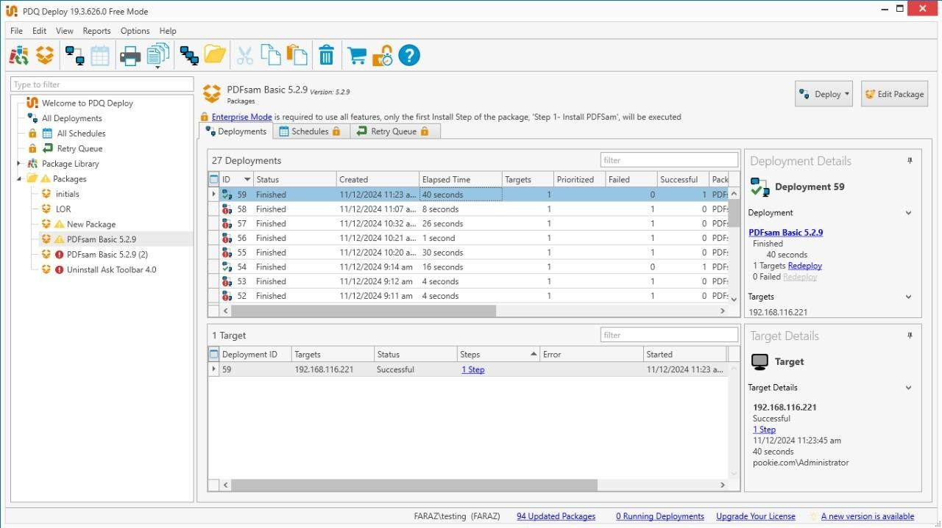

# 5. Conclusion:

The **Remote Software Installation from Server's PC to Client's PC** project has successfully streamlined software deployment across multiple client systems using automation and centralized management. By integrating **Active Directory** for secure access control, **virtualization** for scalability, and **cloud storage** for efficient distribution, the project ensures faster, more reliable deployments. The system reduces operational costs and downtime by automating the installation process and improving resource management. Real-time monitoring and logging enhance troubleshooting and ensure successful installations. Overall, the project has provided a secure, scalable, and efficient solution for remote software deployment.

# 6. References:

1. Abu Sharkh et al. (2020) conducted a comparative analysis of virtualization technologies, including Hyper-V, evaluating their suitability for enterprise network infrastructure and efficiency in resource utilization. IEEE Access.
2. Fawaz and Campbell (2019) explored efficient management and security practices for Active Directory in cloud-based and virtualized environments, addressing challenges in centralized domain control. Proceedings of the ACM on Security and Privacy in Cloud Computing.
3. Torres and Rios (2018) studied automated software deployment in distributed systems, focusing on remote software installation techniques and tools like PDQ Deploy to streamline IT management. Journal of Systems and Software.